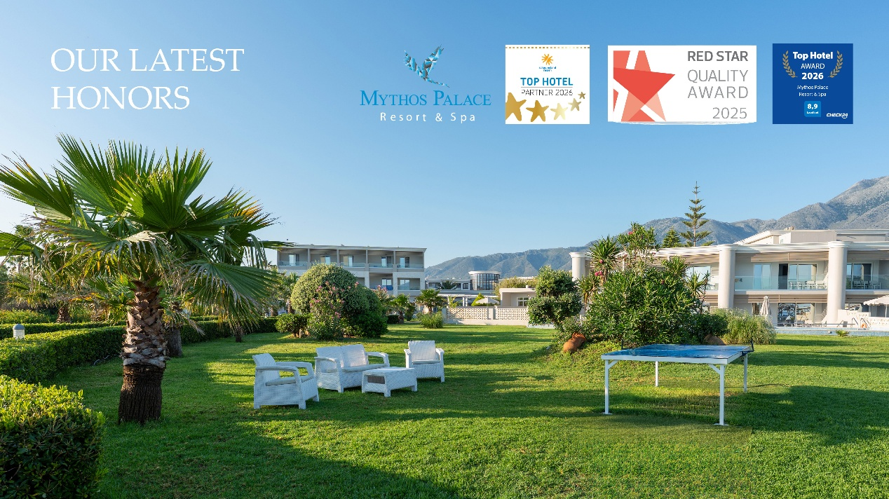
Mythos Palace Resort & Spa Recognized with Leading Hospitality Awards.
Mythos Palace Resort & Spa proudly announces its distinction with three renowned industry awards: the Schauinsland Reisen Top Hotel 2026,
the Red Star Quality Award 2025, and the Check24 Top Hotel Award 2026. These honors are granted based on consistently high guest ratings and reflect excellence in service, comfort, and overall holiday experience.
This achievement reaffirms the resort’s strong focus on quality-driven hospitality and its continuous pursuit of guest satisfaction. Every aspect of the guest journey, from personalized service to the tranquil setting and premium facilities, contributes to the recognition received.
Nestled along the captivating coastline of Crete, Mythos Palace Resort & Spa offers an inviting retreat where relaxation meets refined elegance, creating an ideal destination for travelers seeking both comfort and authenticity.
The team expresses its heartfelt appreciation to all guests whose positive feedback made these award s possible and remains dedicated to delivering exceptional experiences in the seasons ahead.

